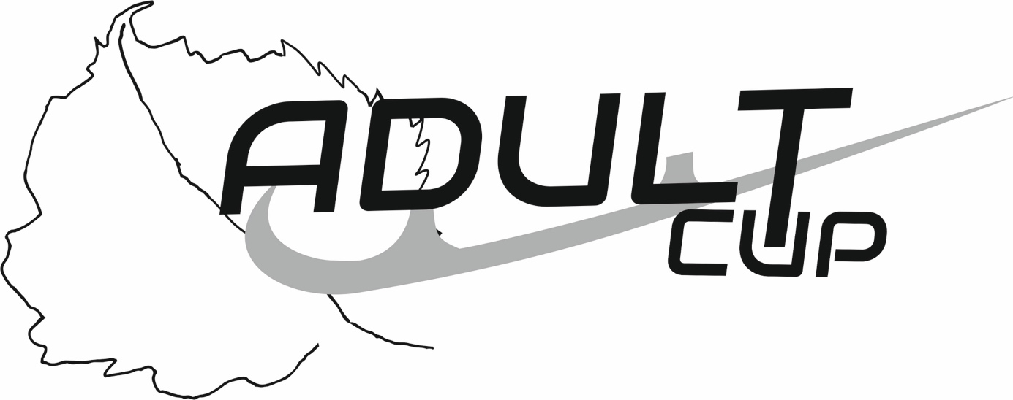
Mariánské Lázně, Czech Republic
April 13th – 16th, 2023

Music Form

ICE LINDEN ADULT CUP 2023

Singles
Name of Competitor:
Category:
Age Category:
Country:

Pairs and Dance
Name of Competitors: | lady
 | man
Category:
Country:

Music Form
Name of music:
Composer: |  | Duration:
Orchstra: |  | Record Label/ Number:

Please send completed Music form to: icelindenadultcup@email.cz
Deadline for Music Forms: March 26, 2022
Please complete this form by computer and "save" to pdf.

