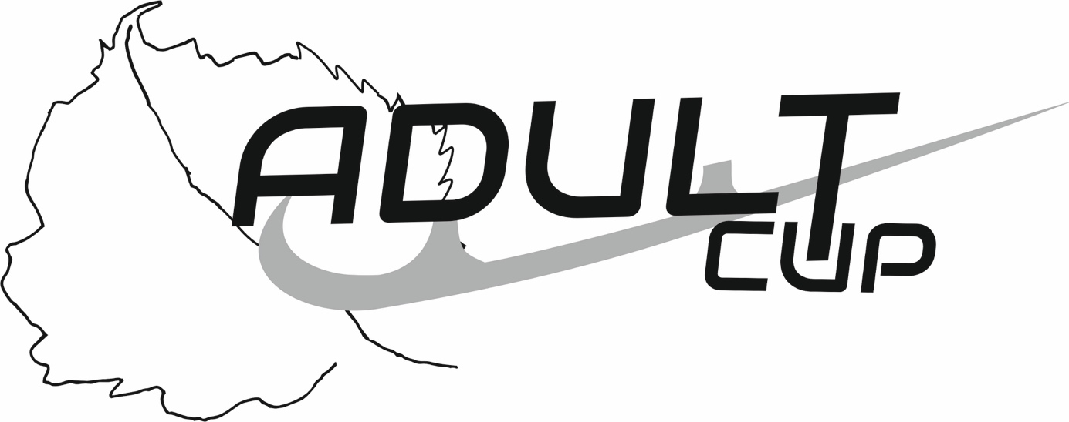
SYNCHRONIZED SKATING
Mariánské Lázně, Czech Republic
April 13th – 16th, 2023
Planned Program Components

ICE LINDEN ADULT CUP - SYNCHRONIZED SKATING

Please submit a copy of this page for each event entered

Name of Team
Name of Club
Team manager

1
2
3
4
5
6
7
8
9
10
11
12

Please send completed PPC form to: icelindenadultcup@email.cz
Deadline for Music Forms: March 26, 2023
Please complete this form by computer and "save" to pdf.

